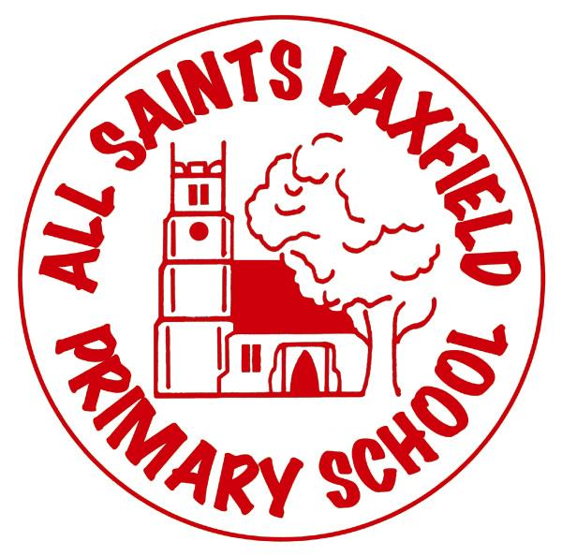All Saints History Curriculum

A family. Uniquely made and loved by God

**Intent**

At All Saints we believe that history helps us all to understand where we have come from. It links with geography, maths, English, art , RE, SMSC and PSHE and can help children understand how people and events of the past have shaped the world they live in today. We want our children to ask questions, analyse evidence, gain a historical perspective, think critically and know facts and information through which these skills can be achieved. We want history to fascinate, inspire and challenge our children to know more about the experience of people in the past in order to learn lessons for the future.

Key concepts

chronology, civilization, community, culture, democracy, development, diversity, empire, evidence, invasion, invention, monarchy, oppression, rebellion, society, source, tyranny,

Our locality

Our locality provides us with a wealth of historical evidence including castles, Anglo-Saxon villages, disused railways and medieval churches. Consequently many of our units of work have a local interest at their heart.

**Implementation** Making history come alive.

Trips, visitors, artifacts, video and primary sources of information are an essential part of helping our children to become fully immersed in the period of time they are studying. These linked with knowledge organisers ensure that the significance of each unit of work is understood.

Due to ever changing year groups, our curriculum extends beyond the National Curriculum to include units of work that we believe deepen children’s understanding of a particular period of time or societal development. Wherever relevant we have linked units to other subjects such as geography or art in order to further develop the children’s understanding.

**Impact** Assessment

Assessment is continuous and evidenced through the use of our marking policy. Assessment occurs through discussion in every lesson but may also be more formal such as a task at the start and end of a topic, mini quizzes or a final piece of writing. History skills as well as factual knowledge will be assessed in order to decide whether a child is working towards, at expected or working above the expected standard.