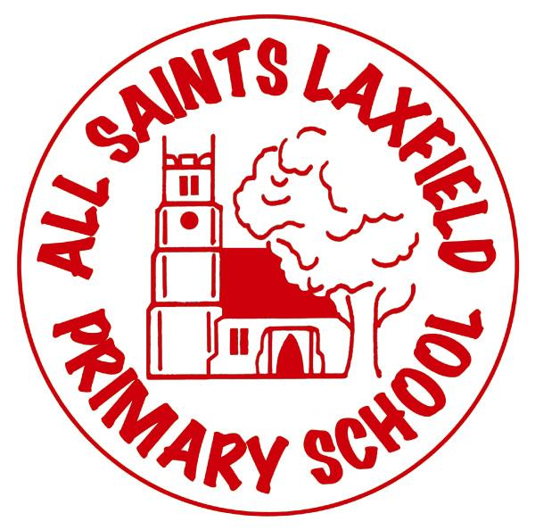 All Saints EYFS Curriculum

A family. Uniquely made and loved by God

**Intent**

At All Saints our main focus is the development and well being of our children. The children’s earliest experiences help them to build a secure foundation for learning and we aim to provide them with the skills, knowledge and understanding they need to prepare them for their future in education and beyond. We want our children to thrive in all areas of the EYFS curriculum by motivating, inspiring and challenging them whilst encouraging them to reflect and think critically. We aim to enable our children to be confident, successful and responsible individuals who can work well together to demonstrate positive examples of our Christian Ethos.

**Implementation**

Our curriculum is carefully organised to suit the needs of our children and create meaningful cross-curricular links. Our pupils learn through a range of child-initiated and adult led activities. This enables the children to be carefully supported and challenged. It is important for early misconceptions to be addressed and for regular feedback to be given to extend the children’s learning.

We value imagination and creativity and aim to develop unique children. We provide many opportunities for the children to share their own experiences and learn from each other. The children are given time to engage in active learning, playing and exploring indoors and outdoors. Our enabling environments and warm, skillful adults help the children build confidence, develop positive relationships and link their learning to their play and exploration.

**Our inclusive approach means that all children learn together** but we have a range of additional intervention to enhance and scaffold children who may need extra support reaching their potential.

Trips, visitors, artifacts, video and exploring the local area are also all an essential part of helping our children to become fully immersed in world we live in and to create fascinating and enjoyable learning experiences for a range of learners.

We recognise the importance of parental involvement and communication to ensure we maximise our children’s learning opportunities and ensure our children and our community are happy. Parents receive curriculum letters, take part in curriculum cafes, meet with staff at parent consultation evenings, see regular updates in their child’s learning journal and frequently communicate with us via their home/school diary. We encourage parents to regularly view their child’s work and progress in the classroom with us too.

**Impact** Assessment

Our assessment is continuous and occurs through ongoing observations, discussions with the children, looking at their work and good communication between staff. We use our marking policy to support analysis of the children’s work and evidence observations via the children’s online learning journals. We use ongoing Bug Club phonics assessments and maths checklists to support our observations.

All of these assessments enable us to create tracked judgements via Arbor and assist us in setting targets and planning experiences accordingly. Our data helps us to regularly monitor our children’s progress towards the ELG’s and ensure they are making GLD expectations.

We believe our high standards are due to our high expectations and the enriched learning experiences we provide for our children along side our careful and detailed teaching and assessment. This supports our children to become inquisitive, responsible and successful learners ready to transition into Year 1.