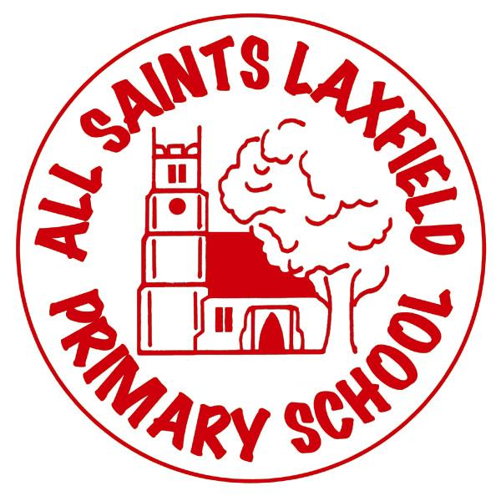All Saints Reading Curriculum

A family. Uniquely made and loved by God

**Intent**

At All Saints, we believe that being able to read fluently and confidently is a key skill and we want our children to be life- long readers. We want our children to enjoy reading, to be excited by the written word and to be successful learners. We believe that every child should be able to access a range of texts, authors and genres to enable them to read for pleasure as well as to learn.

**Implementation** Making reading come alive.

In EYFS and KS1 reading is taught by a daily phonics lesson using Bug Club Phonics. Children are taught to know the sounds of individual letters and how they sound when they are combined. By carefully matching books to the phonics stage a child is at, we ensure that they can apply their phonetic knowledge. Children are read to regularly as well as heard read in school. Picture books and short stories encourage a love of reading and children will often join in with well- known texts.

In KS2 children continue to read individually but reading as a skill is taught through whole class teaching of a single novel. Classes will read up to 6 novels a year in addition to picture books, poetry and non-fiction texts. Every lesson centers around reading aloud, with regular modelling by class teachers. Units of work are planned around the core skills of decoding, vocabulary, inference, prediction, explaining, reasoning and summarizing. Fluency is developed through modelling and re-reading.

Reading links to all subjects across the curriculum. We use great quality texts in many foundation subjects and our new library is full of texts chosen specifically for our children. Once children are ready to move on from phonics based books, they are taught how to choose books from the library or the class library which are suitable for their reading ability and interests. Parents are encouraged to hear their children read daily and record their comments in a home school diary. Children who have completed phase 6 phonics but who need additional support also have Bug Club Phonics decodable books to develop word recognition and fluency. Class reading cafes have been introduced to show parents how we teach reading and recommended book lists have been sent home.

Teachers read children’s books and talk to their classes about reading. Displays about books are evident throughout the school and part of our approach to encouraging reading for pleasure.

**Impact** Assessment

Phonics is assessed regularly in lesson and extra support given to children who need it. Reading is assessed termly with the use of NFER tests. (Year 1 start these in the spring term). In addition to this, children read regularly to adults in a 1:1 situation, whole class guided reading and across the curriculum. They may be given comprehension tasks to complete or be involved in an in-depth discussion about a book, all of which is used by the staff to assess the child’s reading ability.