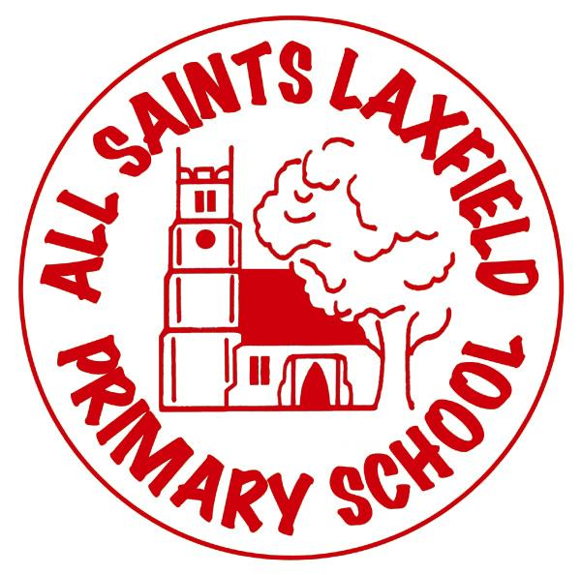All Saints Art Curriculum

A family: uniquely made and loved by God

**Intent**

At All Saints we believe that art is a subject which can inspire and enrich lives. It is an opportunity for self-expression, discovery and imagination. Diverse cultures, emotions, physical landscapes, music and story can all be explored through this technical yet creative subject. We want our children to take risks, experiment, explore, be inspired, reflect and respond to the work created by other artists as well as the world around them. We want them to become proficient in the key skills of drawing, painting, print making, collage, textiles and 3D work while making links to history, geography, computing, RE, music, maths and English.

Key concepts:

Tone, line, texture, pattern, 2D form, 3D form, colour, creativity, imagination, explanation, observation, imagination, exploration, scale, perspective, discovery

Our locality

Our rural locality provides opportunities for sketching varied plant life and buildings from the 15th century. Wherever possible references will be made to local or national artists.

**Implementation** Making Art come alive.

Art is taught regularly at All Saints. Wherever possible children have an art lesson every week. This is a deliberate decision which underlines how important we feel art is to the development of every child.

At All Saints Primary we use the Access Art curriculum. This is divided into six multi-disciplinary pathways, which ensure the development of skills through the integration of different media, continually building on prior learning. Flexibility within the scheme allows teachers to adapt knowledge rich ideas to suit individual students and needs, whilst embracing each child’s creativity with multiple opportunities for exploration. Each pathway follows a particular format, including warm-ups, artist and material critiques and reflections, and challenges or briefs for final pieces. There are plentiful opportunities for repeated practices and new experiences with a range of collaborative and independent activities, which allow more layers of knowledge and skills to be developed, alongside the growth of imagination and ideas.

Visiting artists, a dedicated art display area in the school hall and entry into art competitions ensure that art is celebrated throughout our school. Children’s ideas are developed through the use of sketchbooks, which also have photographs, or original final pieces of work.

**Impact** Assessment

Art is assessed frequently, both during and after each lesson, as well as at the end of each half-termly unit. Frequent assessment ensures pupils are working at their creative potential, whilst enabling ample opportunities for exploration, through the provision of materials, media, modelling and support. Timely verbal feedback is a key assessment tool in each lesson. At the end of each unit, teachers consider knowledge, creativity, skills, evaluation and imagination in both sketchbook work and final pieces, leading to an overall level of working towards, at expected or greater depth. Children assess their own work at the end of every unit, increasingly learning skills in evaluating and critiquing both their own work and that of others. They may also use peer assessment to encourage and challenge each other to improve their work. By the time children leave us is in year 6, we want them to be able to express themselves artistically; have an understanding of a broad range of artists, designers, architects, artwork and skills, and be self-aware, able to self-analyse and be confident in their creative ability.